**TECHNICAL QUESTIONNAIRE**

**REF. IO/MSY/21/RAT/PMT**

**ROBOTIC ARM**

**FOR TIGHTENING M110/M80 FASTENERS**

***Firms interested in participating to this market survey shall return a completed questionnaire to the following email address*** [***philippe.mousset@iter.org***](mailto:philippe.mousset@iter.org) ***, no later than Monday 21 June 2021.***

***Please note that this is not a Call for Nomination request. At this moment the ITER Organization (IO) is preparing a contract and procurement strategy for this project.***

***For all questions in the document, please refer to the ITER Market Survey Technical Requirements ref. ITER_D_54TUDA version v1.1 dated 07 June 2021.***

# *General information about the Company / Institute compiling the questionnaire*

**Company Name**: …………………….

## *Persons to be contacted:*

|  |  |  |  |
| --- | --- | --- | --- |
| ***Contact person*** | ***Name + Title*** | ***Email address*** | ***Telephone*** |
| ***Commercial Matters:*** |  |  | + |
|  |  |  |  |
| ***Technical Matters:*** |  |  | + |
|  |  |  |  |

***Main activities***

|  |  |
| --- | --- |
| ***Main activities*** | ***Description*** |
|  |  |
|  |  |
|  |  |
| ……………………. |  |

***Turnover***

|  |  |  |  |  |
| --- | --- | --- | --- | --- |
| ***Contact person*** | ***Turnover***  ***2018*** | ***Turnover***  ***2019*** | ***Turnover***  ***2020*** | ***Number of employees*** |
| **All activities** |  |  |  |  |
| ***In the field of*** *Robotic Arms*  *(development and manufacturing)* |  |  |  |  |

# *Supplementary Information about Working Conditions*

## Two full sets of tools are used to tighten Upper Pre-Compression Rings (PCRings) and Lower Pre-Compression Rings in parallel.

## It is better not to use hydraulic fluids. (Using lubricants is OK.)

## Working area is conditioned as some clean class and around 20°C air.

## Working area is limited by 4.5m.

## Working floor and support basis are prepared by IO according to requirement of robotics and auxiliaries.

## IO adopt an installation method that minimizes the installation period by unitizing the robots and the auxiliary equipment that should be placed near it. Also, IO adopt all the methods to minimize the set-up time at working area.

* The Counter Flanges move ~15mm outward in radial direction according to loading. MJTs and Jackbolt also move slightly.

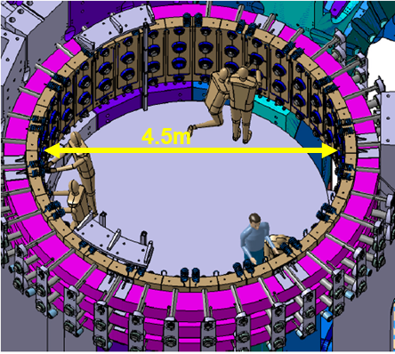

# *Technical Competence and Experience*

* 1. ***Do you think that you can propose full-automated system for ITER PCRing confidently within your experience?***

**YES**  **NO**

If YES, please provide overview of the system, for example, type of robotics, robotics are fixed or move on rail, type of sensors, specification of spindle, etc.:

If NO, please give us the reason why you think it difficult/impossible:

***Below questions are if you are YES in question 3.1***

* 1. ***Are you able to anticipate how long it takes to tighten PCRings per one robot?***

***Please refer to technical requirement for tightening sequence and required steps.***

***Please note that set-up time at actual work area should be included in this anticipation.***

**YES**  **NO**

If YES, please give breakdown of robotics motion times, and nominal robotics continuous running duration:

If NO, please give us breakdown of robotics motions, and each time as much as possible:

* 1. ***Is it possible to use multi robot in same place to shorten tightening duration?***

**YES**  **NO**

If YES, please give your idea how many robots is the best to shorten the tightening duration efficiently. It means that the increase in the number of robot and the shortening of the duration are balanced:

* 1. ***Are you able to provide full-turn-key service, such as design, provision of all components, installation, programming, commissioning*, final set-up and actual operation?***

*Note: “Commissioning*” is expected to take place ahead of execution, on a mock-up to be provided by IO. Full size components for a single sector, so you will have a chance to qualify and debug the system ahead of execution.*

**YES**  **NO**

If YES and if you work with partners, please specify which part of the contract would be taken over by other companies, and in which roles:

# *Project Schedule*

* 1. ***How many months do you need to start actual PCRings tightening from sign of contract?*** *Note: PCRing tightening is scheduled to start at November 2023.*

# *General Questions*

* 1. ***Do you have any concerns to use the robotics for ITER PCRings tightening?***

**YES**  **NO**

If YES, please give us your concerns, for example using multi robotics cannot reduce duration significantly due to anti-collision programing:

* 1. ***Please indicate any other information that may be relevant for this Market Survey.***

# *Quality Assurance*

***Are you certified ISO 9001 or equivalent?***

**YES**  **NO**

***Please specify your certifications.***

|  |  |  |
| --- | --- | --- |
| ***QA Certifications*** | ***Comments*** | ***Validity Period*** |
|  |  |  |
|  |  |  |
|  |  |  |

|  |  |
| --- | --- |
| Signature: | COMPANY STAMP |
| Name: |
| Position: |
| Tel: |
| Date: |